**Hands on 1  
Install Maven in Desktop**   
  
Follow instructions below to setup maven in the desktop: 

1. Download latest version of maven from internet or get the installation zip file from trainer

1. Extract the zip file into D: drive

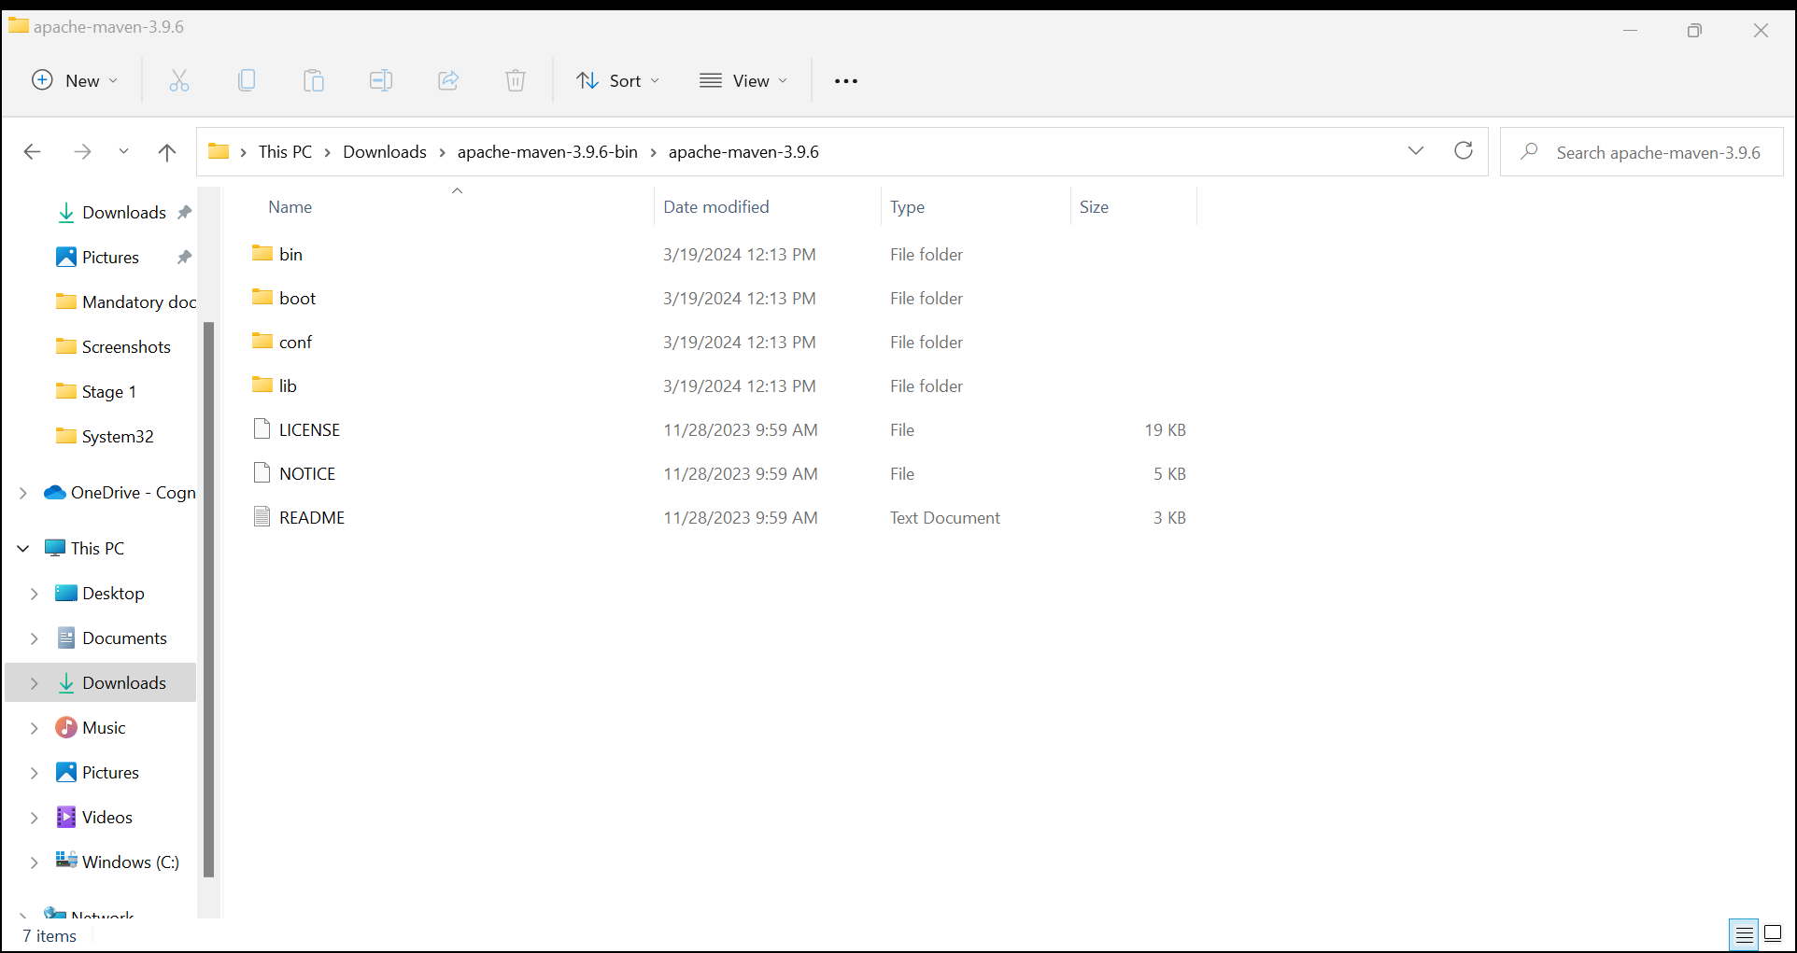

1. Set the windows environment variables JAVA_HOME, MAVEN_HOME

1. Include PATH with MAVEN_HOME\bin

1. Test maven setup with ‘mvn -version’ command in command line

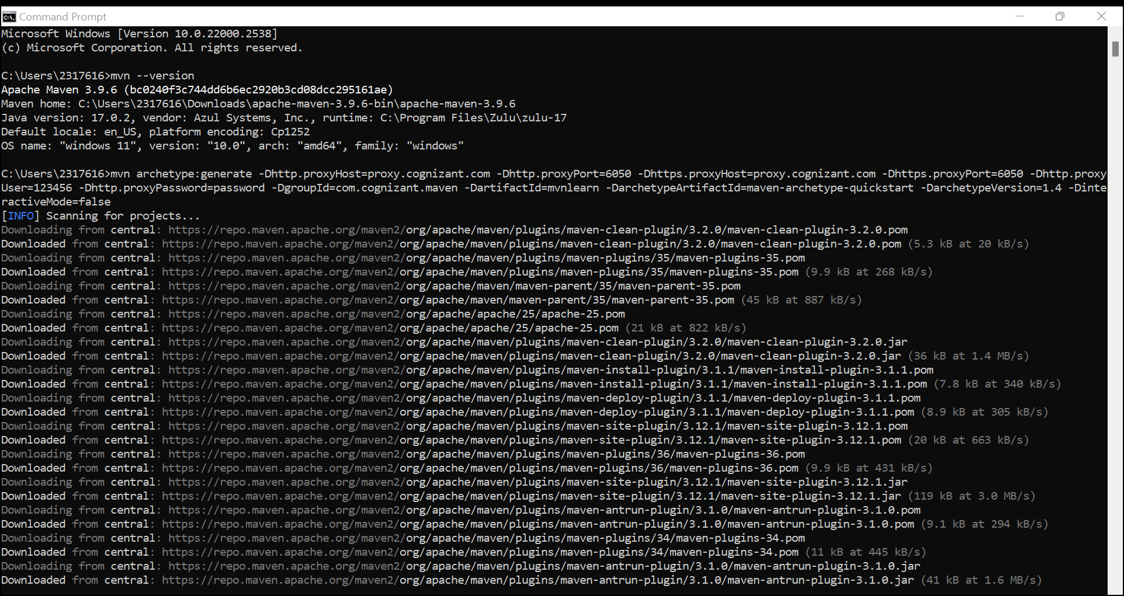

**Hands on 2  
Create web project using Maven**   
  
Follow instructions below to create a web project using Maven: 

1. Open command line
2. Change the folder to the root folder of the Eclipse workspace
3. Execute the following command to create the maven web project structure. Change the proxyUser and proxyPassword accordingly in the command below.

mvn archetype:generate -Dhttp.proxyHost=proxy.cognizant.com -Dhttp.proxyPort=6050 -Dhttps.proxyHost=proxy.cognizant.com -Dhttps.proxyPort=6050 -Dhttp.proxyUser=123456 -Dhttp.proxyPassword=password -DgroupId=com.cognizant.maven -DartifactId=mvnlearn -DarchetypeArtifactId=maven-archetype-quickstart -DarchetypeVersion=1.4 -DinteractiveMode=false

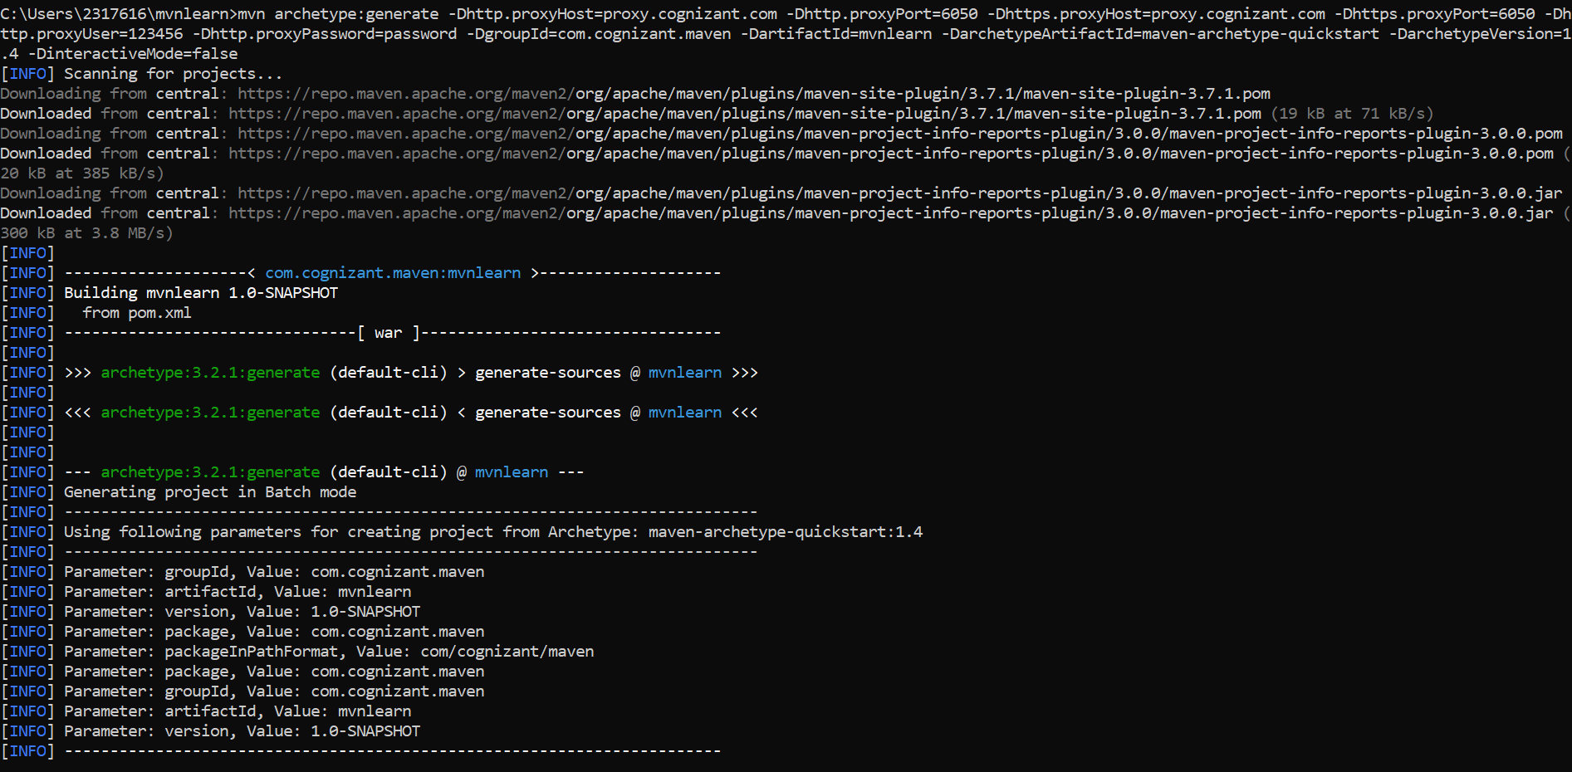

1. Build the project using the following command:

mvn clean package -Dhttp.proxyHost=proxy.cognizant.com -Dhttp.proxyPort=6050 -Dhttps.proxyHost=proxy.cognizant.com -Dhttps.proxyPort=6050 -Dhttp.proxyUser=123456 -Dhttp.proxyPassword=password

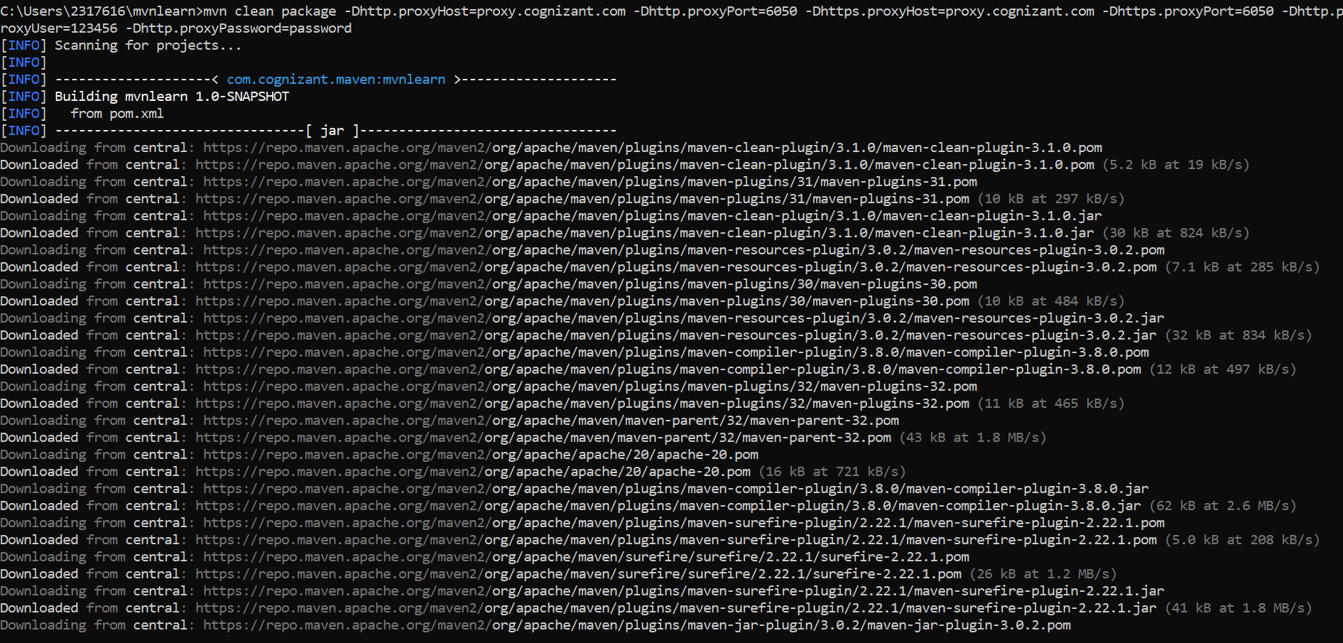

**SME to explain how maven works** 

1. Java libraries are available in central maven repository in internet ([https://repo.maven.apache.org](https://repo.maven.apache.org/))
2. Maven downloads dependent jar files from the central maven repository and places them in C:\Users\[EMP_ID]\.m2\repository folder. This is the local maven repository.
3. This transfer is a one-time activity and download happens only when new dependencies are added in pom.xml.

Refer diagram in Maven Repositories topic of <http://tutorials.jenkov.com/maven/maven-tutorial.html> for understanding the Maven Architecture.

**Hands on 3  
Setup Maven project in Eclipse**   
  
Follow steps below to setup the Maven project in Eclipse. 

1. Import the maven project folder in previous hands on in Eclipse (File > Import > Maven > Existing Maven Projects and select the new maven project folder)

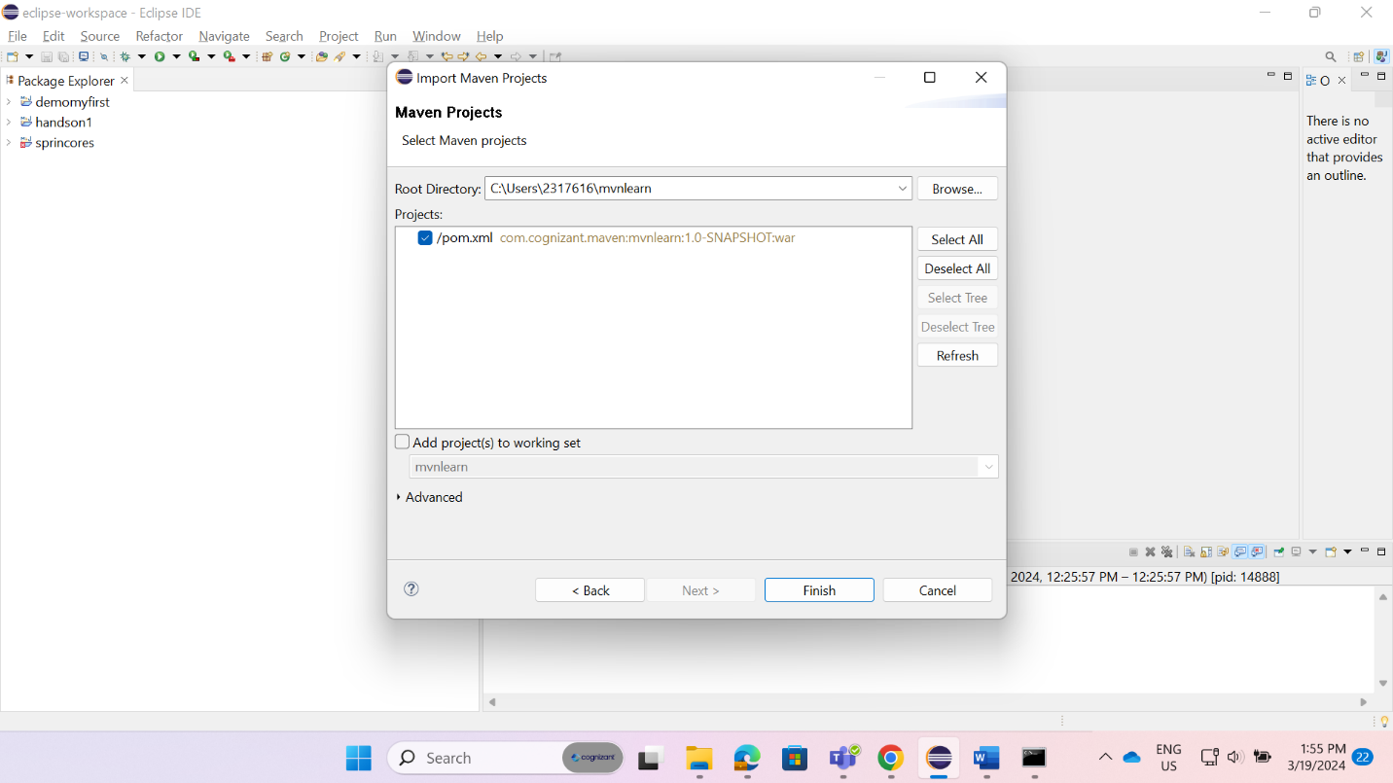

2.Make following change in pom.xml

* 1. Change packaging as war <packaging>war</packaging >
  2. Change compiler version from 1.7 to 1.8

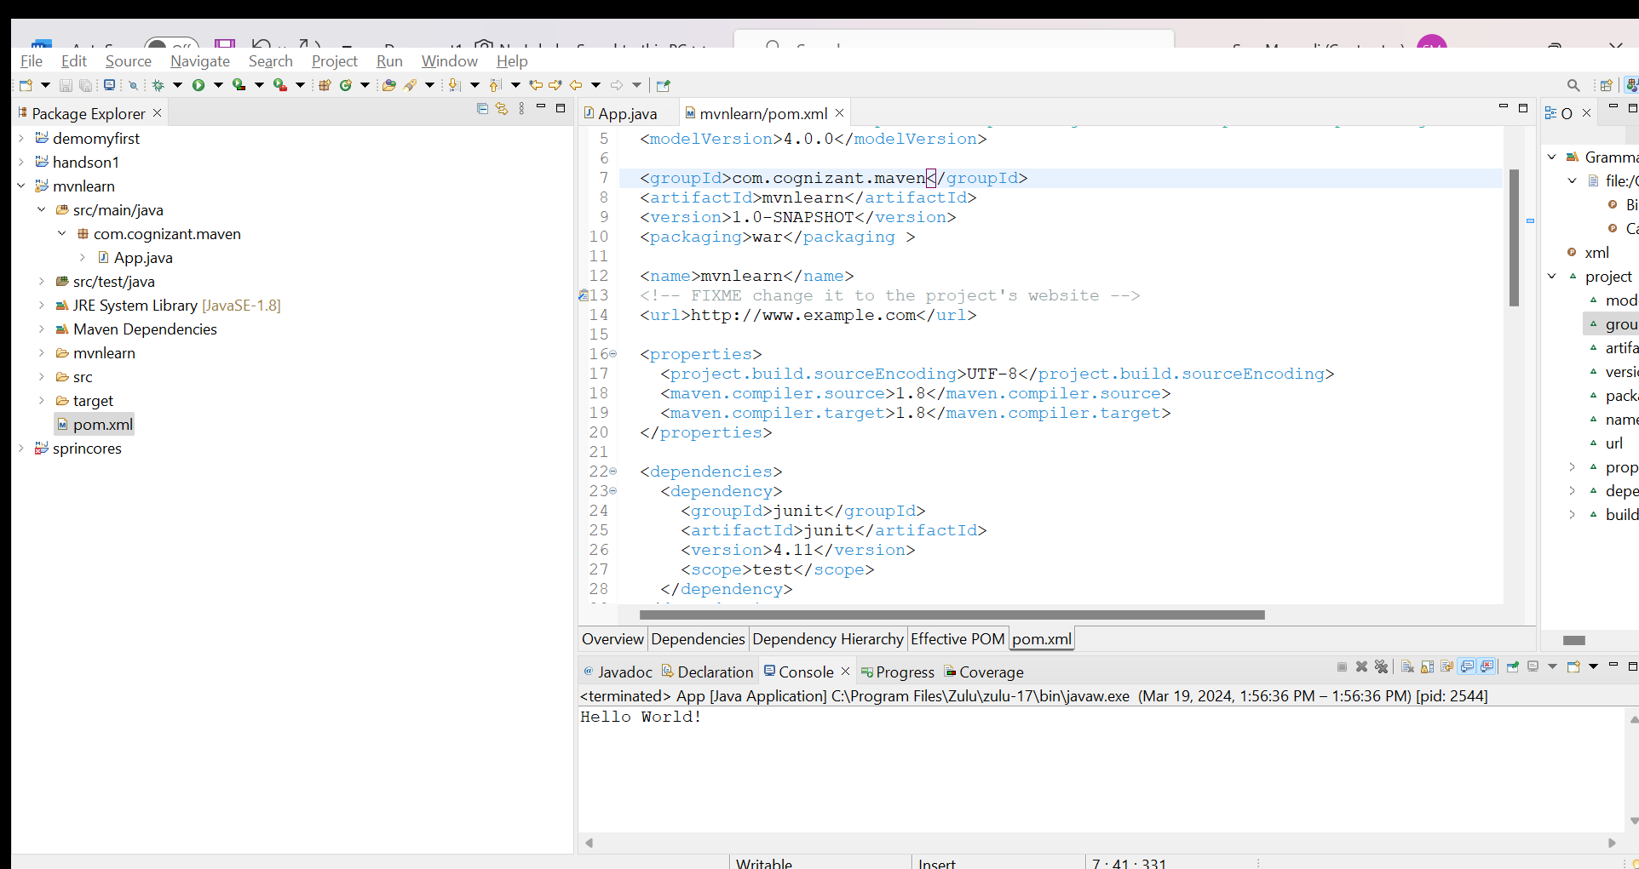

3.Add Tomcat Server Environment as Library (Right Click Project > Build Path > Configure Build Path > Add Library > Server Runtime > Apache Tomcat v9.0)

4.Add the project to Tomcat Server by right clicking the Tomcat Server in Servers perspective and use "Add and Remove" option.

5.Start the server and check if the application is running.

**Hands on 4  
Understanding Maven Build Cycle and Goals**   
  
Execute the following commands in the order specified below.  
  
After executing each command, check the content created in target folder.

|  |  |
| --- | --- |
| **Command** | **Expection action by Maven** |
| mvn clean | Deletes the target folder |
| mvn clean validate | Validates if there is not issues to initiate build |
| mvn clean compile | Compiles and creates the classes from main folder |
| mvn clean test-compile | Compiles and creates the classes from test folder |
| mvn clean test | Executes the unit test cases |
| mvn clean package | Creates the JAR/WAR based on the configuration in pom.xml |
| mvn clean install | Copies the JAR to local maven repository |
| mvn clean deploy | This will fail since the remote server details are not configured. |

1. mvn clean:

1. mvn clean validate:A screen shot of a computer program

   Description automatically generated

3.mvn clean compile:

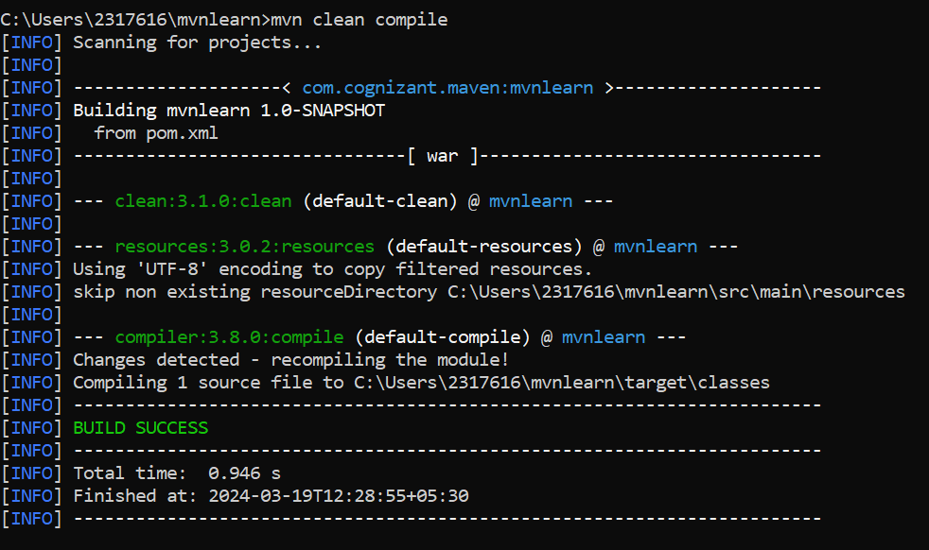

4.mvn clean test-compile:

5.mvn clean test:

1. mvn clean package:

7.mvn clean install:

8.mvn clean deploy:

